The kernel source itself is available from kernel.org
You will need the kernel tar archive file, a rather large file named something like:
linux-release.tar.xz
and the corresponding very small digital signature file:
linux-release.tar.sign
where release is either two or three numbers separated by dots, something like 4.18 or 4.18.6
Uncompress the large tar archive file and verify the digital signature. Do not proceed until you have successfully verified the signature, indicating that you have the real source code from the Linux kernel organization.

You need to understand the Linux release numbering scheme. You will see kernel releases with both two and three numbers. The two-number version represents the release in terms of potential capabilities. They increment as 3.0, 3.1, 3.2, and so on. It rolls over at a fairly arbitrary point.

The third number, if present, represents bug fixes. The 3.19.1 release includes patches to some bugs discovered in the 3.19 release. In turn, the 3.19.2 release includes more patches, the 3.X.Y releases are cumulative bug fixes to 3.X.

The kernel organization has strict rules: 4.X.Y releases must be bug fixes only, no sneaking new features into the kernel before the 4.(X+1) release! And the fixes should be small, involving 100 lines or less of C code.

Vmlinux

On Linux systems, vmlinux is a statically linked executable file that contains the Linux kernel in one of the object file formats supported by Linux, which includes ELF, COFF and a.out. The vmlinux file might be required for kernel debugging, symbol table generation or other operations, but must be made bootable before being used as an operating system kernel by adding a multiboot header, bootsector and setup routines.
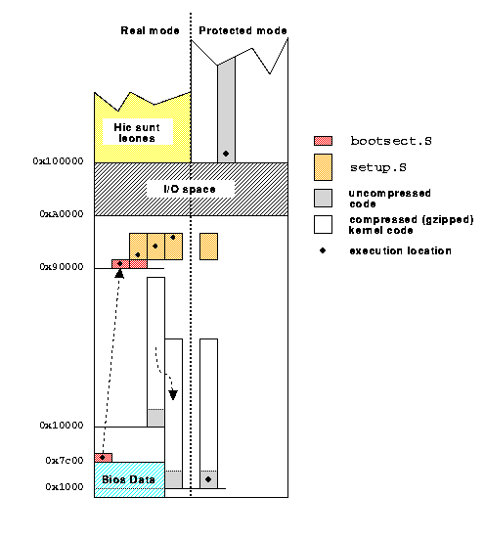

With the development of virtual memory, kernels that supported this feature were given the vm- prefix to differentiate them. The name vmlinux is a mutation of vmunix, while in vmlinuz the letter z at the end denotes that it is compressed (for example gzipped).

Traditionally, the kernel was located in the root directory of the filesystem hierarchy; however, as the bootloader must use BIOS drivers to access the hard disk, limitations on some i386 systems meant only the first 1024 cylinders of the hard disk were addressable.

To overcome this, Linux distributors encouraged users to create a partition at the beginning of their drives specifically for storing bootloader and kernel related files. GRUB, LILO and SYSLINUX are common bootloaders.
By convention, this partition is mounted on the filesystem hierarchy as /boot. This was later standardised by the Filesystem Hierarchy Standard (FHS) which now requires the Linux kernel image to be located in either / or /boot, although there is no technical restriction enforcing this

Traditionally, when creating a bootable kernel image, the kernel is also compressed using gzip, or since Linux 2.6.30,[3] using LZMA or bzip2, which requires a very small decompression stub to be included in the resulting image. The stub decompresses the kernel code, on some systems printing dots to the console to indicate progress, and then continues the boot process

The decompression routine is a negligible factor in boot time, and prior to the development of the bzImage, the size constraints of some architectures, notably i386, were extremely limiting, making compression a necessity.

The filename of the bootable image is not important, but many popular distributions use vmlinuz.

bzImage -
As the Linux kernel matured, the size of the kernels generated by users grew beyond the limits imposed by some architectures, where the space available to store the compressed kernel code is limited.
The bzImage (big zImage) format was developed to overcome this limitation by splitting the kernel over discontiguous memory regions.
The bzImage file is in a specific format. It contains concatenated bootsect.o + setup.o + misc.o + piggy.o

piggy.o contains the gzipped vmlinux file in its data section (ELF) (see compressed/Makefile piggy.o). All source files mentioned are in arch/i386/boot/.

The script extract-vmlinux found under scripts/ in the kernel sources decompresses a kernel image.

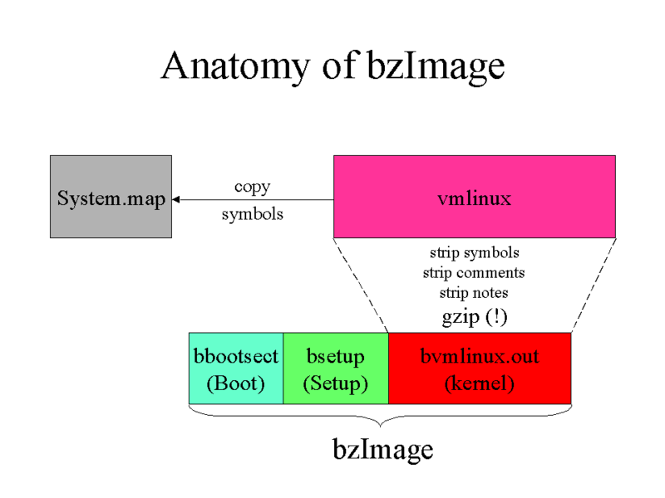

uImage

This is bootable image for a processor, which uses u-boot as bootloader. The processors are like ARM (32-bit), PowerPC, MIPS. There is a utility tool "mkimage" to transform vmlinux into uImage. The uImage has the following header in the beginning of image.
typedef struct uimage_header {
uint32_t ih_magic; /* Image Header Magic Number (BE) */
uint32_t ih_hcrc; /* Image Header CRC Checksum (BE) */
uint32_t ih_time; /* Image Creation Timestamp (BE) */
uint32_t ih_size; /* Image Data Size (BE) */
uint32_t ih_load; /* Data Load Address (BE) */
uint32_t ih_ep; /* Entry Point Address (BE) */
uint32_t ih_dcrc; /* Image Data CRC Checksum (BE) */
uint8_t ih_os; /* Operating System */
uint8_t ih_arch; /* CPU architecture */
uint8_t ih_type; /* Image Type */
uint8_t ih_comp; /* Compression Type */
uint8_t ih_name[IH_NMLEN]; /* Image Name */
} uimage_header_t;

Here we can have a brief overview on various kernel images ….
- Image: The generic Linux kernel binary image file.
- vmlinux:This is the Linux kernel in an statically linked executable file format. Generally, you don’t have to worry about this file, it’s just a intermediate step in the boot procedure.The raw vmlinux file may be useful for debugging purposes.
- vmlinux.bin:The same as vmlinux, but in a bootable raw binary file format. All symbols and relocation information is discarded. Generated from vmlinux by objcopy -O binary vmlinux vmlinux.bin.
- vmlinuz:The vmlinux file usually gets compressed with zlib. Since 2.6.30 LZMA and bzip2 are also available. By adding further boot and decompression capabilities to vmlinuz, the image can be used to boot a system with the vmlinux kernel. The compression of vmlinux can occur with zImage or bzImage.The function decompress_kernel() handles the decompression of vmlinuz at bootup, a message indicates this:
Decompressing Linux... done
Booting the kernel.
- zImage (make zImage): This is the old format for small kernels (compressed, below 512KB). At boot, this image gets loaded low in memory (the first 640KB of the RAM).
- bzImage (make bzImage) : The big zImage (this has nothing to do with bzip2), was created while the kernel grew and handles bigger images (compressed, over 512KB). The image gets loaded high in memory (above 1MB RAM). As today’s kernels are way over 512KB, this is usually the preferred way.
- uImage: an image file that has a U-Boot wrapper (installed by the mkimage utility) that includes the OS type and loader information.

